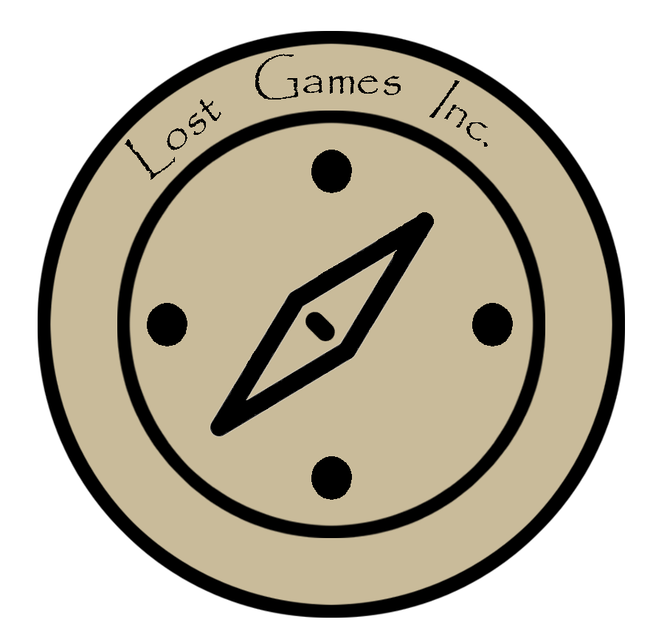

Scrum Sprint 0

Team A4

Emily Timarky, Christian Colaiezzi, Sydney Halk,

Kevin Conway, Sadjell Mamon

**Description:**

This report details user stories and test cases for each bug and enhancement found in the SER 225 game.

**User Stories:**

**Start Menu with Instructions**

* As a gamer, I would like to be able to view instructions on the game menu so that I can start the game with an understanding of how to play. (Test Plan ID: A1)

**Audio and Animations**

* As a gamer, I would like to be able to see and hear sounds/animations so that the game is exciting and enjoyable to play. (Test Plan ID: A2)

**Narrative**

* As a gamer, I would like a back story to the game as a source of motivation as to why it is that I am playing the game. (Test Plan ID: B1)

**Adding Levels**

* As a gamer, I would like additional levels to the game that you pass on to when you win each level so that the duration of the game is longer. (Test Plan ID: B2)

**Power-Up Ability**

* As a player, I want to get power-ups so they can help me progress through the more difficult levels of the game. (Test Plan ID: C1)

**Key Bindings**

* As a player, I want to be able to move the character with input keys that I am comfortable with such as WASD and spacebar. (Test Plan ID: D1)

**Environment Interaction**

* As a player, I do not want to get stuck under the map and have to reset the game.
* As a player, I expect to either die or be able to swim in the water as these are common in other games. (Test Plan ID: D2)

**Increase Level Difficulty**

* As a player, I want the game to increase difficulty so the game is enjoyable and challenging to play. (Test ID: E1)

**User should be able to kill/harm enemies**

* As a developer, I want to allow users to kill the enemies so the cat is more likely to avoid being killed. (Test ID: E2)

**Test Cases:**

**Title:** *Start Menu With Instructions*

**Owner of Test:** *Emily Timarky*

**Tester:** *Harrison Dewhurst*

**Test ID:** *A1*

**Date Tested:** *September 13, 2020*

|  |  |  |  |
| --- | --- | --- | --- |
| **Step** | **Action** | **Expected Result** | **Pass/Fail** |
| 1 | Start the game and have the ability to look at instructions | Menu screen features instructions for how to start | F |
| 2 | Game window pops up and it has an option to view instructions | Gamer can click “X” to view the instructions on a new window | F |
| 3 | Gamers with little experience can see that clicking the space bar will start the game | Users are able to start the game with little difficulty. | F |
| 4 | Game screen allows users to click on “START GAME” to start the game | Players begin the game using clickable start and enter the game smoothly. | F |

*Overall Result of Test: Failure*

**Title:** *Audio and Animations*

**Owner of Test:** *Emily Timarky*

**Tester:** *Amy Nicoloff*

**Test ID:** *A2*

**Date Tested:** *9/13/2020*

|  |  |  |  |
| --- | --- | --- | --- |
| **Step** | **Action** | **Expected Result** | **Pass/Fail** |
| 1 | Game’s menu screen features an upbeat theme song | Once the frame pops up, a song begins to play that matches the theme of the game. | F |
| 2 | Cat is killed by the enemies in the game | User runs into an enemy and the cat falls off the screen with a sound in the background. | F |
| 3 | Cat jumps up and hits the gold box at the end of the game | Screen reads level cleared, and a celebratory audio plays | F |
| 4 | Cat jumps up in the air to get over an object/enemy. | Bouncing sound can be heard when cat jumps up | F |
| 5 | Cat falls into the water | Cat begins to swim and the sound of rushing water can be heard | F |

*Overall Result of Test: Failure*

**Title:** *Narrative*

**Owner of Test:** *Sydney Halk*

**Tester:** *James Heuschkel*

**Test ID:** *B1*

**Date Tested:** *September 18, 2020*

|  |  |  |  |
| --- | --- | --- | --- |
| **Step** | **Action** | **Expected Result** | **Pass/Fail** |
| 1 | Press “Play Game” and another screen will pop up before the game actually starts. | The screen will read that the cat the gamer is playing is trying to cross these fields to get back to his cat family who he lost in a storm. | F |
| 2 | The game starts and the gamer starts playing, word bubbles will pop up on the screen. | The word bubbles will read when that cat crosses an obstacle, “Yes, I am getting closer to my cat family!” | F |
| 3 | While in contact with the enemies, more word bubbles will pop up. | These word bubbles will read, “You’re not going to stop me from getting back to my family!” | F |
| 4 | If the gamer dies while in contact with the enemy another word bubble will pop up before the game closes or resets back to the main menu. | The word bubble will read, “No, I won’t reach my family now!” | F |
| 5 | If the gamer wins the game, another screen will pop up before the game resets to the main menu or closes. | This screen will show the cat with his whole cat family and saying, “Yay! I made it back!” | F |

*Overall Result of Test: Failure*

**Title:** *Adding Levels*

**Owner of Test:** *Sydney Halk*

**Tester:** *Brigid Halk*

**Test ID:** *B2*

**Date Tested:** *September 18, 2020*

|  |  |  |  |
| --- | --- | --- | --- |
| **Steps** | **Action** | **Expected Result** | **Pass/Fail** |
| 1 | Start the game and press “Play Game.” | The game starts and the gamer plays the first level. | F |
| 2 | The gamer passes the first level. | Before moving up to level 2, a screen will pop up saying “Congratulations you made it to level 2!”The player will play level 2 of the game. | F |
| 3 | This will repeat for another 10 levels, so a total of 12 levels. | After each level is passed, a screen will pop up saying, “Congratulations you made it to level #!” This is assuming they pass each level. | F |
| 4 | If the player does not pass a level | A screen will pop up saying, “Level not passed” and will have the option of repeating the level or exiting the game. | F |
| 5 | All 12 levels are passed by the gamer. | The gamer completed the game. | F |

*Overall Result of Test: Failure*

**Title:** *Power-Up Ability*

**Owner of Test:** *Kevin Conway*

**Tester:** *Jack Post*

**Test ID:** *C1*

**Date Tested:** *September 18, 2020*

|  |  |  |  |
| --- | --- | --- | --- |
| **Steps** | **Action** | **Expected Result** | **Pass/Fail** |
| 1 | Run Game | Game boots up | P |
| 2 | Press Play | Game starts | P |
| 3 | Hit yellow box at end of level | Player gets power-up | F |

*Overall Result of Test: Failure*

**Title:** *Key Binding Test*

**Owner of Test:** *Christian Colaiezzi*

**Tester:** Josh Erazo

**Test ID:** *D1*

**Date Tested:** *September 22, 2020*

|  |  |  |  |
| --- | --- | --- | --- |
| **Steps** | **Action** | **Expected Result** | **Pass/Fail** |
| 1 | When in the game press “D” | Player moves to the right | F |
| 2 | When in the game press “A” | Player moves to the left | F |
| 3 | When in the game press “W” | Player jumps | F |
| 4 | When in the game press “S” | Player crouches | F |
| 5 | When in the game press “Spacebar” | Player jumps | F |

*Overall Result of Test: Failure*

**Title:** *Environment Test*

**Owner of Test:** *Christian Colaiezzi*

**Tester:** James Salgado

**Test ID:** *D2*

**Date Tested:** *September 22, 2020*

|  |  |  |  |
| --- | --- | --- | --- |
| **Steps** | **Action** | **Expected Result** | **Pass/Fail** |
| 1 | Run all the way to the left at the start of the game | Hit a wall that stops you from walking any further | F |
| 2 | Run all the way to the right at the end of the game | Hit a wall that stops you from walking any further | F |
| 3 | Jump into the water | Restart the level or lose a life | F |
| 4 | Run into the walrus | Stop from walking and must jump over. | F |

*Overall Result of Test: Failure*

**Title:** *Increase Level Difficulty*

**Owner of Test:** *Sadjell Mamon*

**Tester:** Saichah Paul

**Test ID:** *E1*

**Date Tested:** *September 22, 2020*

|  |  |  |  |
| --- | --- | --- | --- |
| **Steps** | **Action** | **Expected Result** | **Pass/Fail** |
| 1 | End first level | At some point, user completes first level | F |
| 2 | Design new environment | Game environment changes with more dangerous traps | F |
| 3 | Put more obstacles in players’s path | User has to jump or go under to get through them | F |
| 4 | Increase the number of enemies | The player will have to confront more dangerous enemies | F |

*Overall Result of Test: Failure*

**Title:** *Allow the player to attack/kill enemies*

**Owner of Test:** *Sadjell Mamon*

**Tester:** Diderot Paul

**Test ID:** *E2*

**Date Tested:** *September 22, 2020*

|  |  |  |  |
| --- | --- | --- | --- |
| **Steps** | **Action** | **Expected Result** | **Pass/Fail** |
| 1 | Allow the player to fight with hands | The player will be able to hit enemies with punches and kicks. | F |
| 2 | Allow the player to kill with guns | The player will have a gun to kill his enemies. | F |
| 3 | Make enemies weaker when hit by player | The enemies will be weaker when they are hit; this makes them more vulnerable. | F |
| 4 | Allow player to take part of enemies’ health when they are attacked | As the enemies are hit by the player, they will lose health, which will be transferred to the player. | F |

*Overall Result of Test: Failure*

**Git Repository:**

*Below is the Git link to the repository for the project.*

[*https://github.com/etimarky/TeamA4*](https://github.com/etimarky/TeamA4)